strategies for black box testing
- random testing (okeh)
  - valid testing strat
  - can use random inputs (num generator)
+ can get weird outliers
+ joyful!
+ easy implementation
+ good if you don’t understand the spec
+ luck
- could test the same inputs again
- time consuming
- might not find bugs
- Decision table (meh)
  - list out all possible decisions
+ will def test all possibilities - exhaustive
+ easy implementation
+ helps spot gaps in reqs
+ good for testing interactions b/w conditions
- might not be able use decision table approach (testing file upload func, as there are infinite file sizes)
- ridiculous # tests
- time consuming
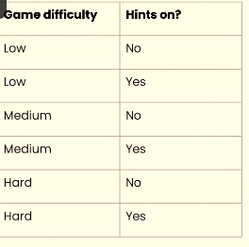
- Category partition testing (meh)
  - checks categories of inputs
  - like decision table
+ can turn something hard to test w/ decision table by turning it into a category (YouTube filters, # minutes of video can be turned into short, med, long)
+ handles inputs w/ discrete options well
- relies on approp categorisation
- not possible will every kind of input
- exp # test cases
- equivalence partitioning testing (good)
  - helps narrow down cases
+ good for continuous input
+ more efficient (less test cases)
- might not get outliers
- non-exhaustive
- hard to get approp partitions
- boundary value analysis (good)
  - helps cover edge cases
+ checks high risk inputs
+ small # high value tests
- only checks boundary values
- relies on good identification of boundaries
- tradeoff b/w coverage & feasibility

